Q2. CREATE A REPORT

STEPS TO CREATE A REPORT

BUILD A REPORT MANUALLY

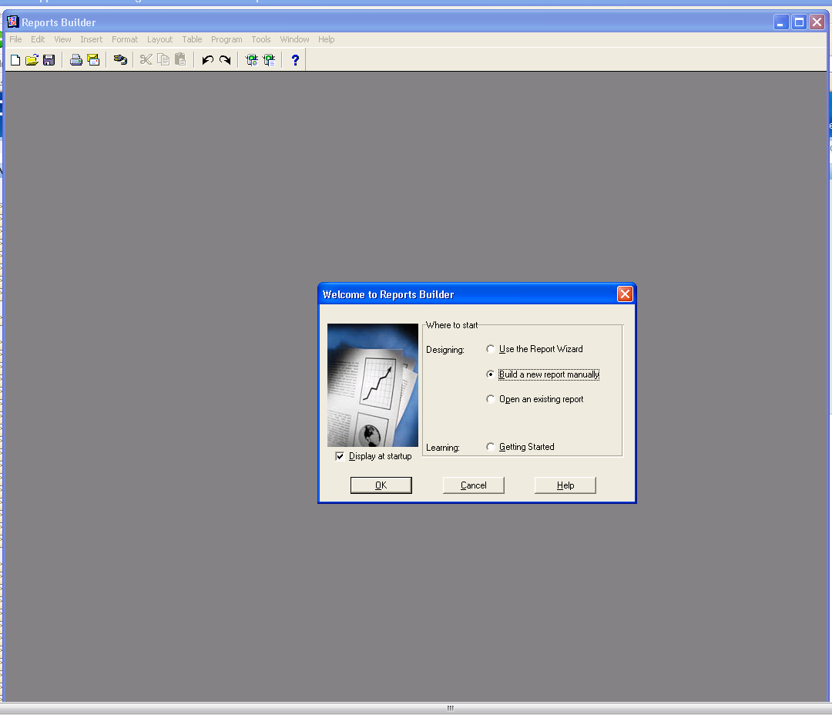

OPEN DATA BLOCK USING REPORT BUILDER

COMMAND: SELECT ALL FROM SCOTT.EMP

USERNAME; hr

PASSWORD: hr

DATABASE: EG30790

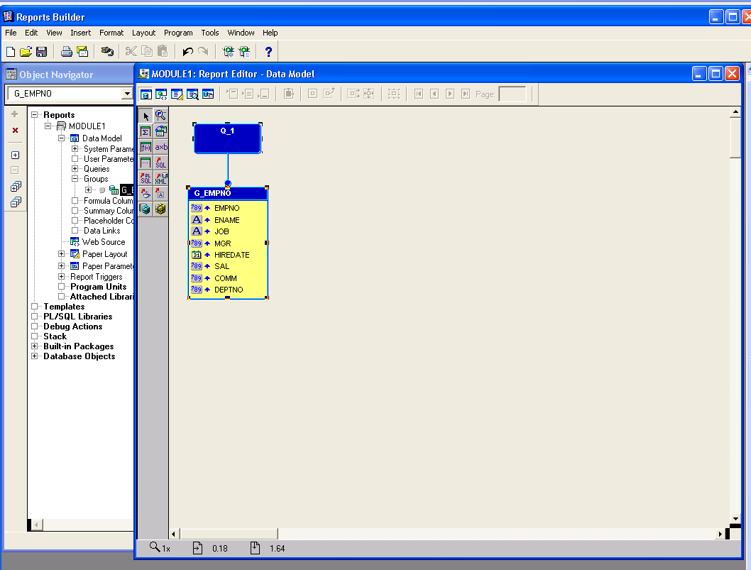

CHANGE THE REPEATING FRAME NAME

SOURCE: EMPNO

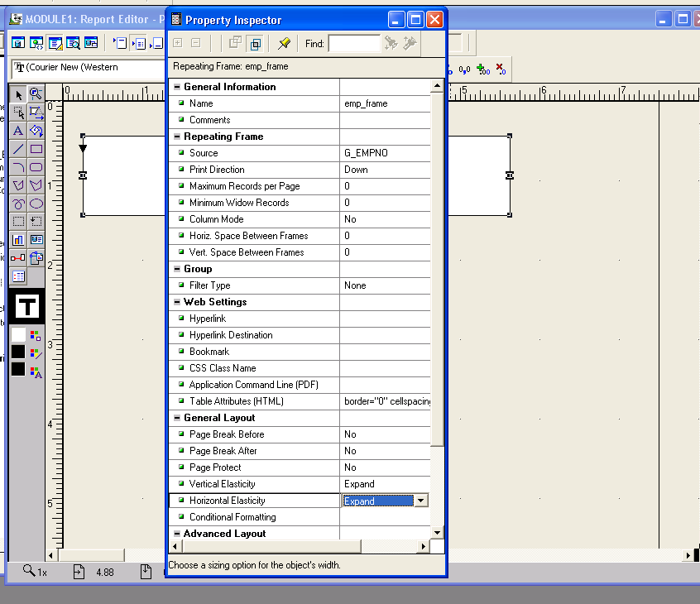

CREATE A FIELDS LIKE

EMPNO ENAME JOB MANAGER HIREDATE SAL COMM DEPTNO

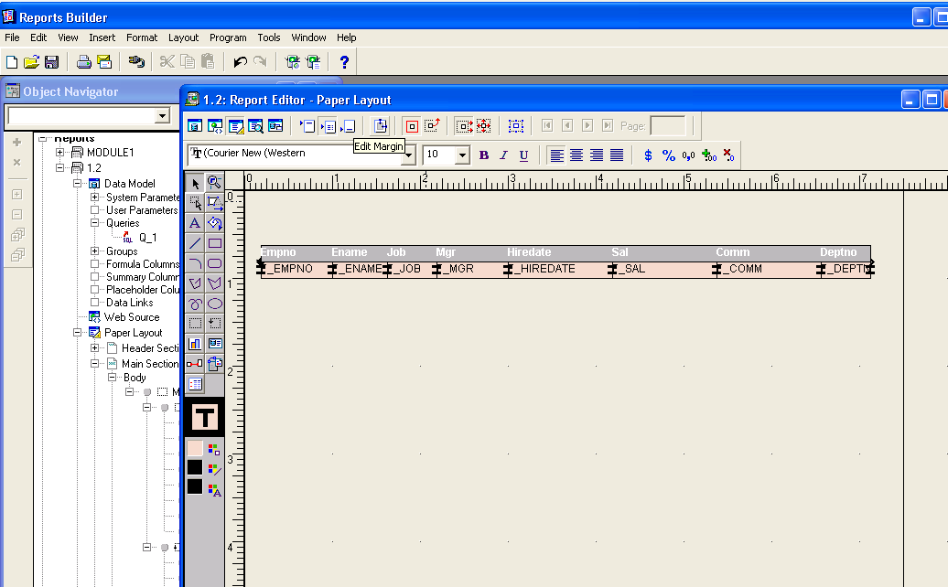

RUN THE FORM AND

SEE OUTPUT

IN PAPER LAYOUT

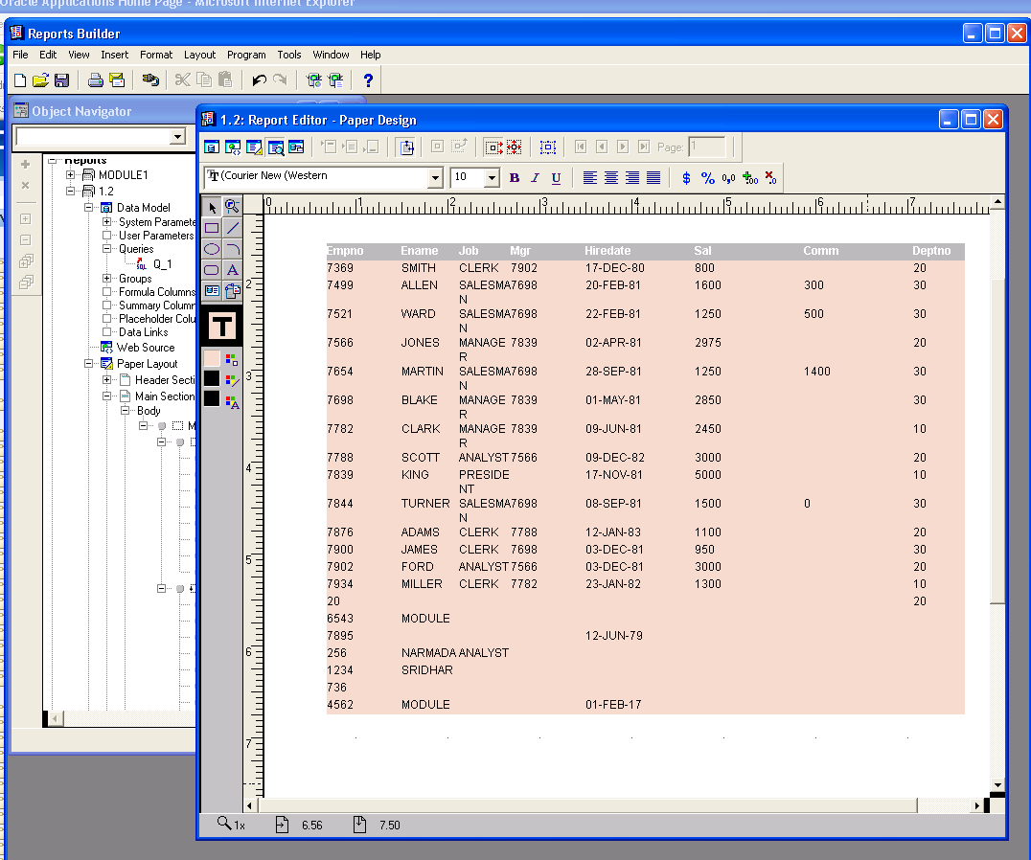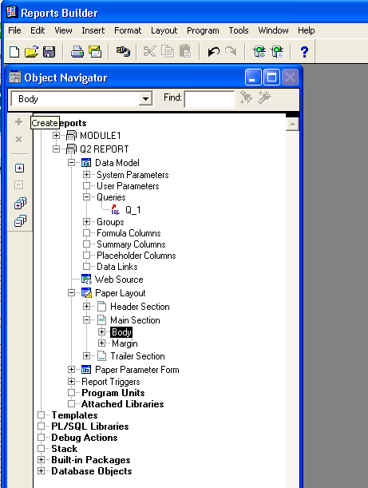

NOW USING WINASP

TAKE IT TO SERVER TO THE PATH

DBFILES/APPLCSF/CUST/REPORTS/US

BINARY TRANSFER SETTINGS

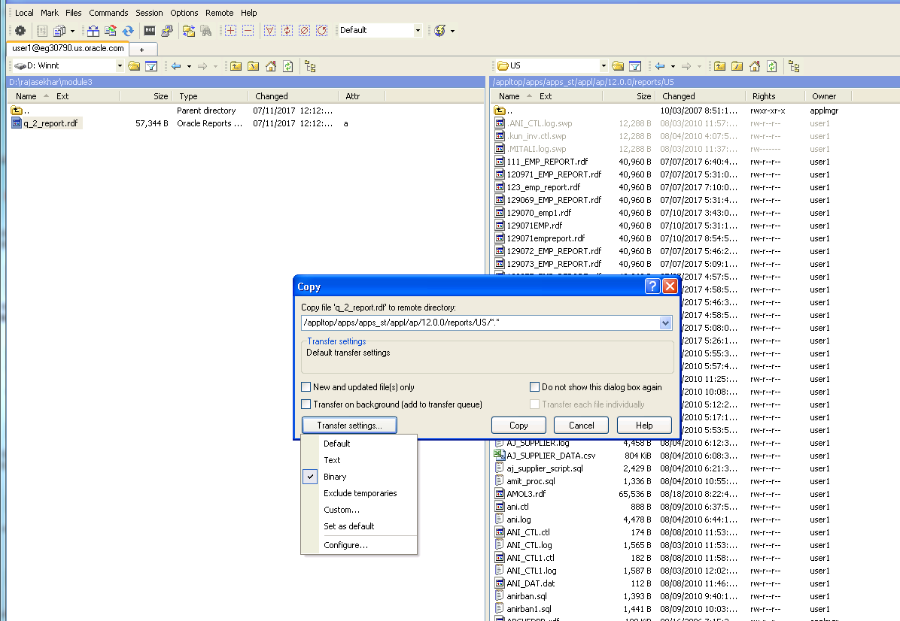

Q3) REPORT

CLICK ON RUN

ON OPENING THE ORACLE SERVER DATABASE

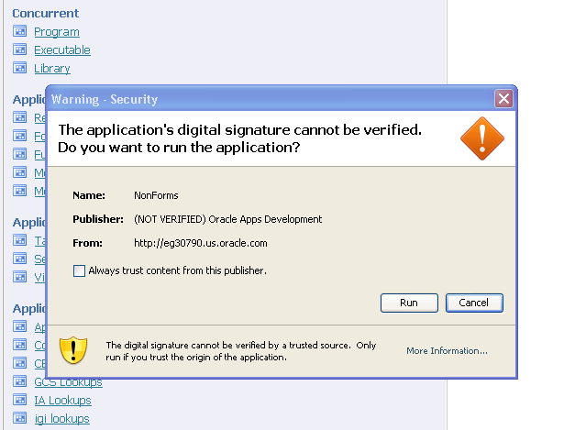

**Step 1 :**

Open Oracle application developer server and open application developer responsibility

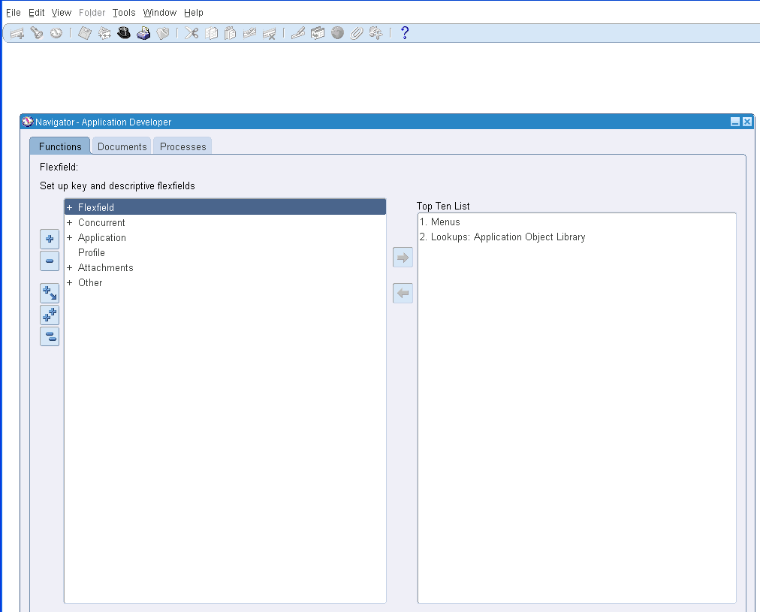

Step2:

Select Concurrent and navigate to Executable

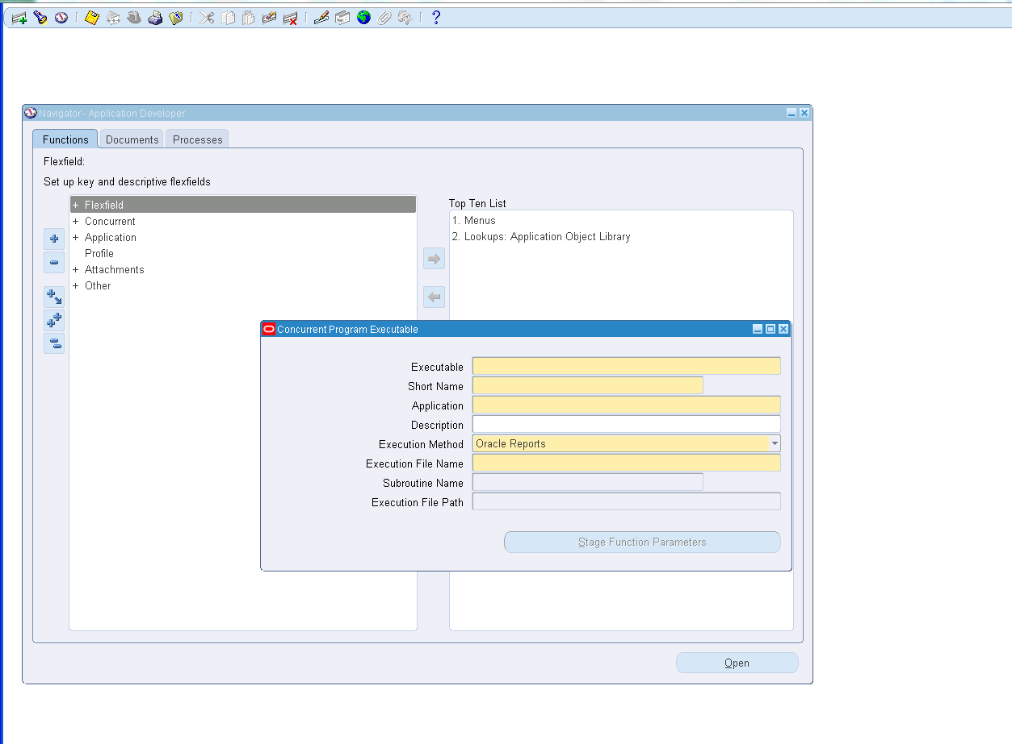

Step 3:

Fill with compiled Report details

Executable – Q_2_REPORT

Short Name – Q_2_REPORT

Application – Custom Development

Execution File Name- Q_2_REPORT

And Save it and exit

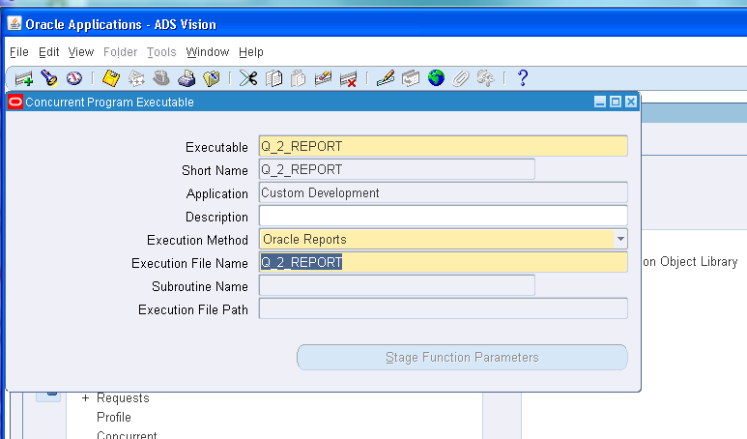

Step 4:

Navigate to Program

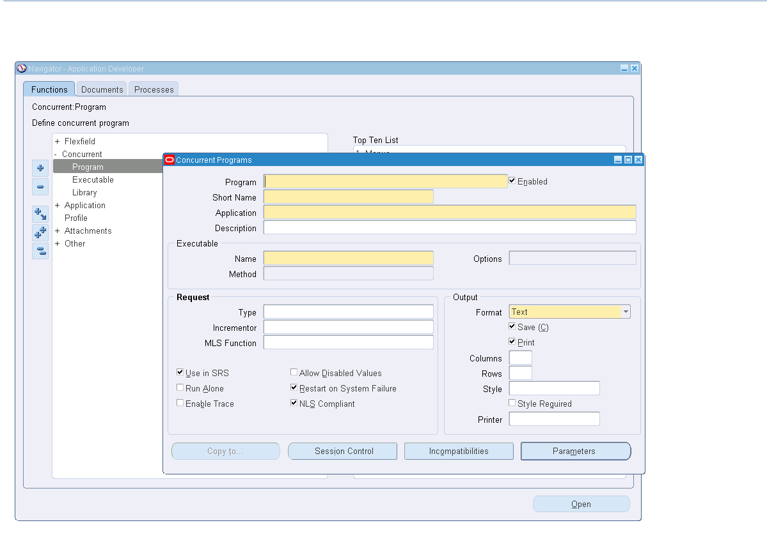

Step 5:

Program – Q_2_REPORT

Short Name – Q_2_REPORT

Application – Custom Development

Name – Q_2_REPORT

Format – Text

Style – A4

And Save it and exit

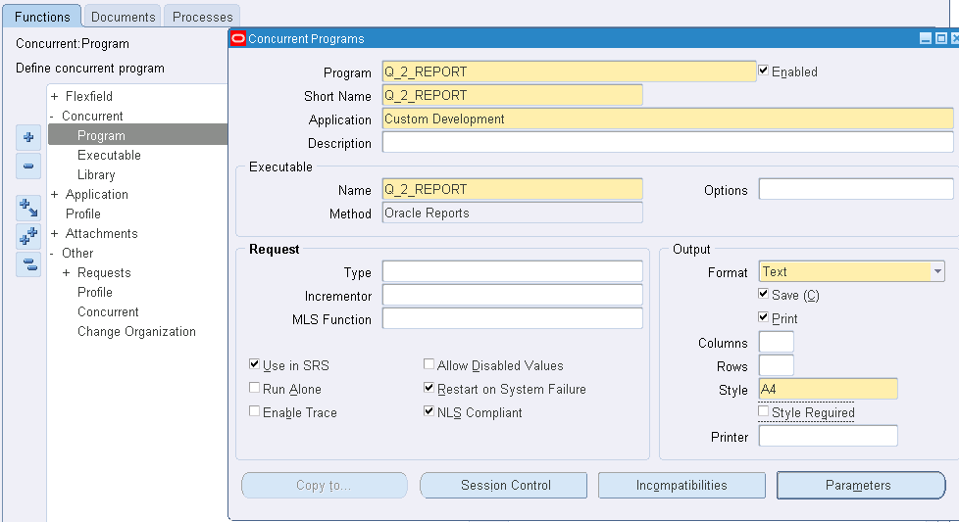

Step6:

Switch responsibility to custom responsibility

And navigate to System Administrator in Custom Responsibility

Click on Security 🡪 Responsibility 🡪 Request.

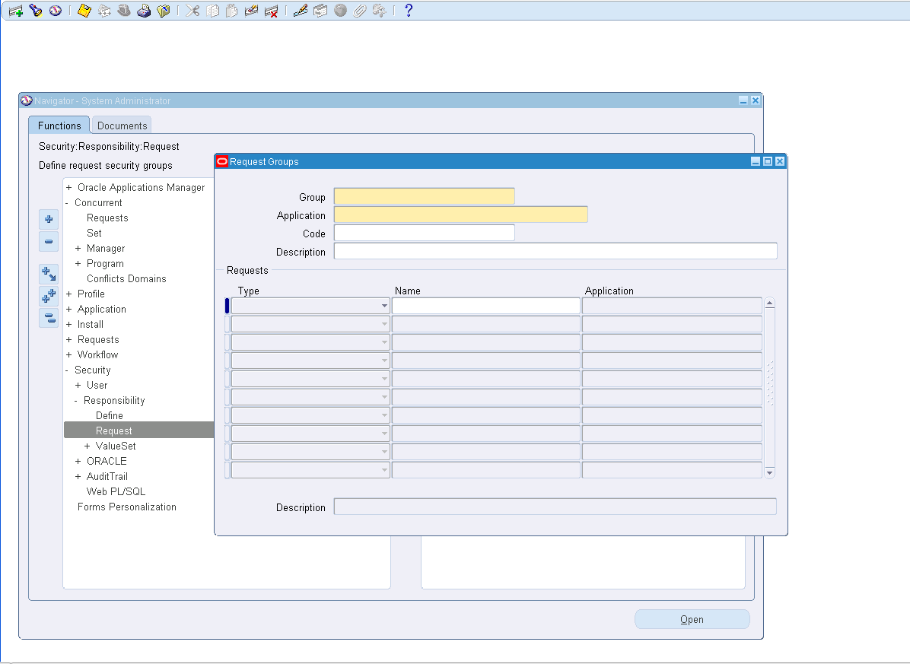

Step 7:

Create a new Request with the details

Group – All Reports

Application – Payables

Requests

Type – Program

Name – Q_2_REPORT

And Save it and exit

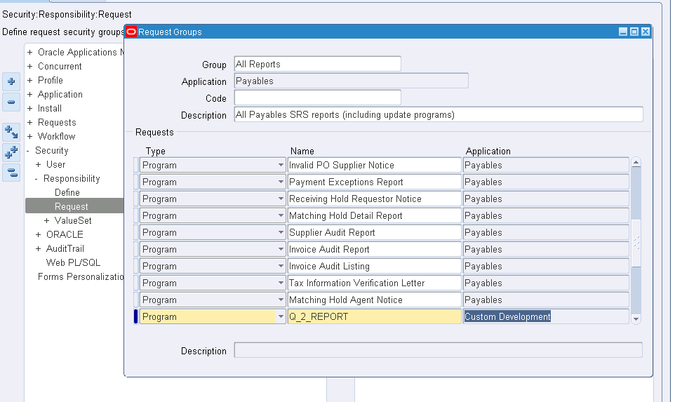

Step 8:

Switch responsibility to custom responsibility

And navigate to Payables, Vision operations (USA) in Custom Responsibility

Navigate to Others 🡪 Requests 🡪 Run

Click on Single Request and then click OK.

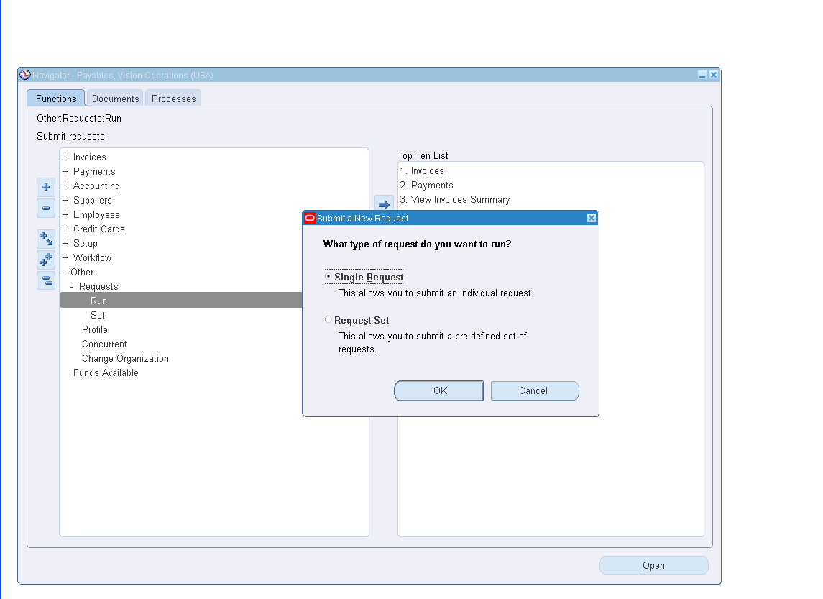

Step 9 :

Name – Q_2_REPORT

Click On Submit .

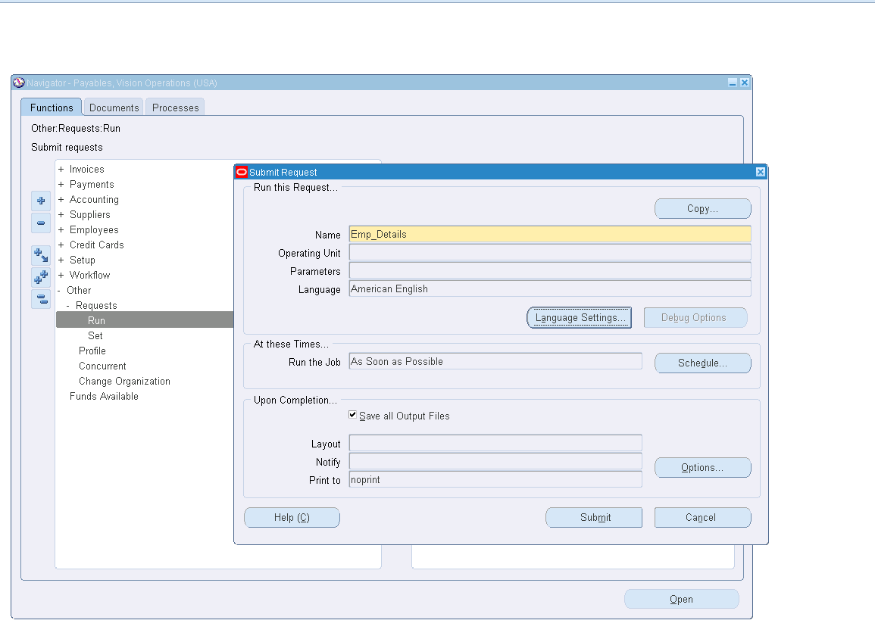

Step 10 :

A window will be displayed with the RequestId i.e.,

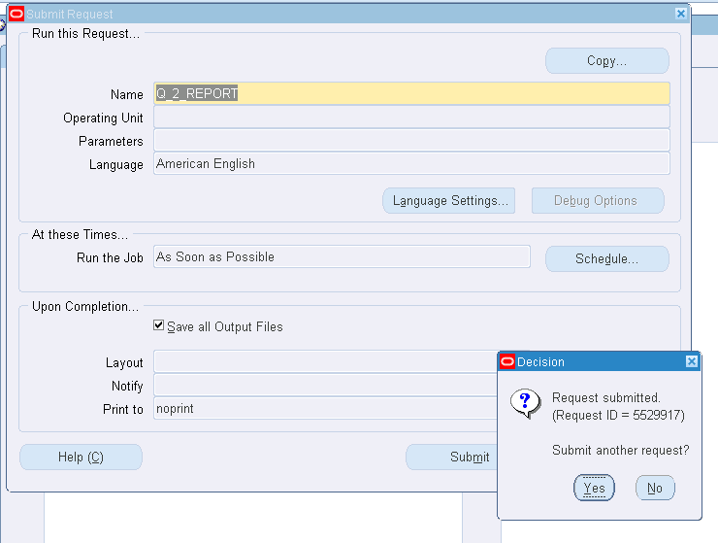

Step 11 :

Click on View tab in the menu bar and click on Requests

Click on Find buttom and select Request ID=5529945

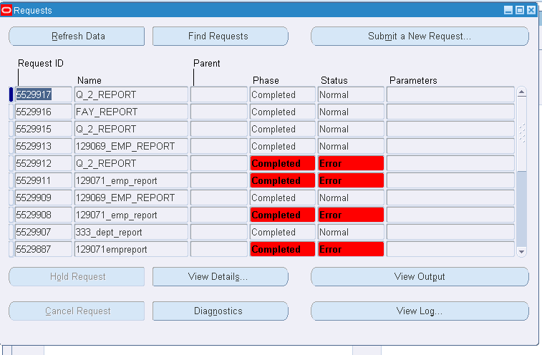

Step 12:

Click on View Output

